**GAS LEAKAGE MONITORING AND ALERTING SYSTEM FOR INDUSTRIES**

USING IOT

*A Project report submitted in partial fulfilment of 7th semester in degree of*

BACHELOR OF ENGINEERING

IN

**COMPUTER SCIENCE AND ENGINEERING**

***Submitted by***

Team ID: PNT2022TMID44022

|  |  |
| --- | --- |
| MONISHA G | 723719104048 |
| SARANYA S | 723719104070 |
| RUBHA SHRI V | 723719104068 |
| RITIKA G | 723719104065 |
|  |  |



**DEPARTMENT OF COMPUTER SCIENCE AND ENGINEERING VSB COLLEGE OF ENGINEERING TECHNICAL CAMPUS COIMBATORE**

ANNA UNIVERSITY: CHENNAI 600025

**NOV-2022**

**BONAFIDE CERTIFICATE**

Certified that this project report “**GAS LEAKAGE MONITORING AND ALERTING SYSTEM FOR INDUSTRIES”** is the bonafide record work done by **G.MONISHA** (**723719104048**), **S.SARANYA**(**723719104070**), **V.RUBHA SHRI**(**723719104068**), **G.RITIKA**(**723719104065**) for **IBM-NALAIYATHIRAN** in **VII** semester of **B.E.,** degree course **in Computer Science and Engineering** branch during the academic year of 2022 - 2023.

# Staff-In charge Evaluator

**Mrs.V.RADHA Mr.M.BHARATHI RAJA**

# Head of the Department

**Mr.P.DINESHKUMAR**

**ACKNOWLEDGEMENT**

We express our breathless thanks to our **Dr.V.VELMURUGAN M.E., Ph.D.,** the Dean(i\c), VSB College of Engineering Technical campus, Coimbatore, for giving constant motivation in succeeding in our goal.

We acknowledge our sincere thanks to Head of the Department (i/c) **Mr.P.DINESHKUMAR M.E.,** for giving us valuable suggestion and help towards us throughout this Project.

We are highly grateful to thank our Project coordinator **Mrs.V.RADHA M.E.,** and our Project Evaluator **Mr.M.BHARATHI RAJA M.E.,** Department of Computer Science and Engineering, VSB College of Engineering Technical Campus, Coimbatore, for the coordinating us throughout this Project.

We are very much indebted to thank all the faculty members of Department of Computer science and Engineering in our Institute, for their excellent moral support and suggestions to complete our Project work successfully.

Finally our acknowledgment does our parents, sisters and friends those who had extended their excellent support and ideas to make our Project a pledge one.

**MONISHA.G**

**SARANYA.S**

**RUBHA SHRI.V**

**RITIKA.G**

**TABLE OF CONTENTS**

**1.INTRODUCTION**

1.1 PROJECT OVERVIEW

1.2 PURPOSE

**2.LITERATURE SURVERY**

2.1 EXISTING PROBLEM

2.2 REFERENCES

2.3 PROBLEM STATEMENT DEFINITION

**3.IDEATION AND PROPOSED SOLUTION**

3.1 EMPATHY MAP CANVAS

3.2 IDEATION AND BRAINSTROMING

3.3 PROPOSED SOLUTION

3.4 PROBLEM SOLUTION FIT

**4.REQUIREMENTS ANALYSIS**

4.1 FUNCTIONAL REQUIREMENTS

4.2 NON-FUNCTIONAL REQUIREMENTS

**5.PROJECT DESIGN**

5.1 DATAFLOW DIAGRAM

5.2 SOLUTION AND TECHNICAL ARCHITECTURE

5.3 USER STORIES

**6.PROJECT PLANNING AND SCHEDULING**

6.1 SPRINT PLANNING AND ESTIMATION

6.2 SPRINT DELIVERY SCHEDULE

6.3 REPORTS FROM JIRA

**7.CODING AND SOLUTIONING**

7.1 FEATURE 1

7.2 FEATURE 2

**8.TESTING**

8.1 TESTCASES

**9.RESULTS**

9.1 PERFORMANCE METRICS

**10.ADVANTAGES AND DISADVANTAGES**

**11.CONCLUSION**

**12.FUTURE SCOPE**

**13.APPENDIX**

**SOURCE CODE**

**GITHUB & PROJECT DEMO LINK**

**INTRODUCTION**

**PROJECT OVERVIEW**

LPG cylinder plays a major role in our day to day life. LPG cylinder used in several places like social unit, business and Industrial. The domestic class of LPG cylinder contains 14.2 kilo LPG within the cylinder. Similarly, the business and Industrial classes of LPG cylinders contain 19.0 and 35 kg of LPG. LPG Gas leaks have been increased from 10.74% of all kitchen accidents to 15.6% of all the kitchen accidents The small LPG cylinder of weight 5kg in which the burner is located immediately over the cylinder without using a rubber tube is seen to be safer than the one which uses a rubber pipe as this subway has the hazards of getting cracked which in turn can make way to leakage. Worldwide societies of scholars, performers, programmers, and specialists have assembled around this open-source program. The project entitled” LOBO **(LPG OUTFLOW BROWNOUT)**”, will be a great help in terms of preventing any danger caused by gas leakage. The purpose of this project is to detect the presence of LPG leakage as a part of a safety system. Apart from sound alarm, it will shut down the total power due to gas leakage. We use a gas sensor to monitor the LPG if the gas leak reaches beyond the normal level, and it has the high sensitivity and fast response time. This proposed project will trigger the sound alarm. In addition, automatically the power supply will be dripped off. The people can be saved from a potential explosion caused by gas leakage.

**PURPOSE**

LPG cylinder plays a major role in our day to day life. LPG cylinder used in several places like social unit, business and Industrial. The domestic class of LPG cylinder contains 14.2 kilo LPG within the cylinder. Similarly, the business and Industrial classes of LPG cylinders contain 19.0 and 35 kg of LPG. LPG Gas leaks have been increased from 10.74% of all kitchen accidents to 15.6% of all the kitchen accidents The small LPG cylinder of weight 5kg in which the burner is located immediately over the cylinder without using a rubber tube is seen to be safer than the one which uses a rubber pipe as this subway has the hazards of getting cracked which in turn can make way to leakage. Worldwide societies of scholars, performers, programmers, and specialists have assembled around this open-source program. The project entitled” LOBO **(LPG OUTFLOW BROWNOUT)**”, will be a great help in terms of preventing any danger caused by gas leakage. The purpose of this project is to detect the presence of LPG leakage as a part of a safety system. Apart from sound alarm, it will shut down the total power due to gas leakage. We use a gas sensor to monitor the LPG if the gas leak reaches beyond the normal level, and it has the high sensitivity and fast response time. This proposed project will trigger the sound alarm. In addition, automatically the power supply will be dripped off. The people can be saved from a potential explosion caused by gas leakage

**EXISTING PROBLEM**

Compress Natural Gas (CNG) & Liquefied Petroleum Gas (LPG) are common gases used in home & automobiles. Although they are very user friendly & less pollutant, they are hazardous if leakage occurs by any accident. It detects the gas leakage by gas sensor and sends an alert to the registered mobile with the help of the GSM module. Manual work is needed to turn off the gas. It also monitors the gas level if it decreased then the system will intimate to the user by sending SMS and new LPG cylinder booked automatically.

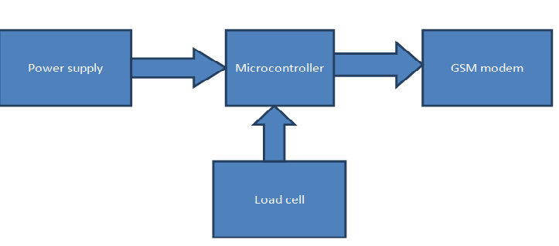

**Block Diagram for Existing System**

Drawbacks

Some of the drawbacks are:

* In this system MQ 5 series sensors are used to detect the gas leakage.
* Not suitable for remote monitoring
* Manual work is needed.

**REFERENCES**

1. Abhishek. G. B. C. V. K. G. S. V. H., B. N. V, Bharath.P, “Automation of LPG cylinder booking and leakage monitoring system,” International Journal of Combined Research and Development (IJCRD), pp. 693–695, 2016.
2. Abid Khan .S. K. D. P. S. R, Neju K. Prince, “GSM based automatic LPG ordering system with leakage alert” IJRET, Vol. 3, 2014. 9.
3. Ankit Sood, Babalu Sonkar, Atul Ranjan, Ameer Faisal, “Microcontroller Based LPG Gas Leakage DetectorUsing GSM Module, International Journal of Electrical and Electronics Research, Vol.3, Issue.2, pp: (264-269), Month: April- June 2015.
4. Avinash M, Sathwik Rai M.S, “Smart home for elder care,” IJARCET, vol. 6, 2017.
5. Brush A.J., Lee. B., Mahajan. R, Agarwal. S, Saroiu. S, & Dixon. C, (2011, May). Home automation in the wild: challenges and opportunities. In Proceedings of the SIGCHI Conference on Human Factors in Computing Systems (pp. 2115-2124). ACM.
6. Chraim. F, Erol.Y, and Pister.K, “Wireless gas leak detection and localization,” IEEE Trans. Ind. Inf., pp. 1 –13, 2015.
7. Denis Spirjakin .A. M. B, “Internet connected wireless combustible gas monitoring system for apartment buildings,” Proceedings of the Conference on Computer Science and Information Systems, Vol. 11, 2018.
8. Gupta .A, “LPG leakage detector and auto shut-off system using Arduino UNO ATmega328,” International Journal of Innovative Research in Science, Engineering and Technology, Vol. 6, 2017. 10.
9. Jolhe. N. S. G. B. D. and Potdukhe P.A, “Automatic LPG booking, leakage detection and real time gas measurement monitoring system,” International Journal of Engineering Research & Technology (IJERT), vol. 2, April-2013.
10. Kasar M.S, Rupali Dhaygude, Snehal Godse and Sneha Gurgule,” Automatic LPG Gas Booking and Detection System”, International Journal of Advanced Research in Electrical, Electronics and Instrumentation Engineering, ISSN 2278-8875, Vol. 5, Issue 3, pp. 1250-1253, March 2016.
11. Naresh Nuke .S. K. K. T. K. R. R, Siva Nagendra Reddy .P, “Arduino based LPG gas monitoring, automatic cylinder booking with alert system,” IOSR Journal of Electronics and Communication Engineering (IOSR-JECE), Vol. 11, 2016. 8.
12. Pruthvi M.R, “Centralized LPG cylinders theft detection system with security alerts,” 12. International Journal of Computer Science and Information Technology Research 8, vol. 4, 2016.
13. Sivajothi Kavitha .S and Senthilkumar .S, "A Wireless Gas Leakage & Level Detection with Auto Renewal System ", International Journal of Advanced Research in Electrical, Electronics and Instrumentation Engineering, ISSN 2278-8875, Vol. 4, Issue 4, pp. 2095-2100, April 2015.

**PROBLEM STATEMENT DEFINITION**

The Liquefied Petroleum Gas (LPG) is the generally used for all cooking purpose in hotels and homes. Also, it is very user friendly to all the users, even though lot of explosions are occurred because of LPG outflow. In our system we are implemented a module to overcome these issues faced by the society LOBO is a system which is incorporated with gas sensor to sense the gas outflow. If the sensor senses the gas outflow level and compare this with the threshold value which is already set in the software. If it exceeds the fixed threshold value means buzzer gets activated and relay which is connected to the circuit also switched on. Then the total power supply will be dripped off.

**IDEATION & PROPOSED SOLUTION**

**Empathy Map Canvas**

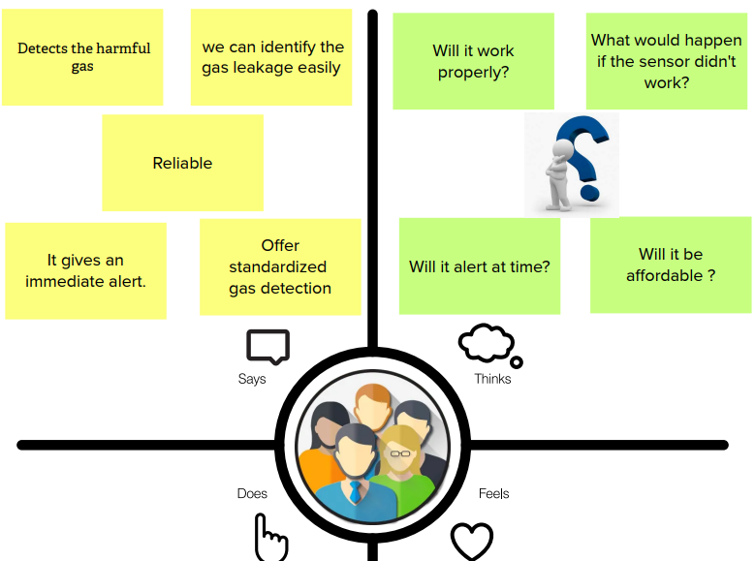

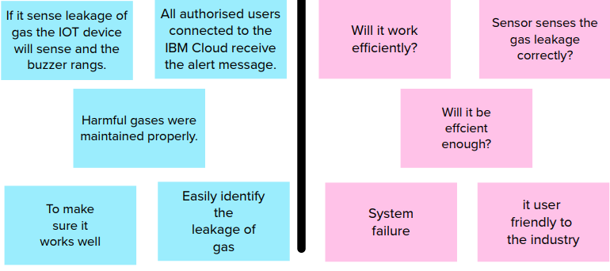

**Ideation & Brainstorming**

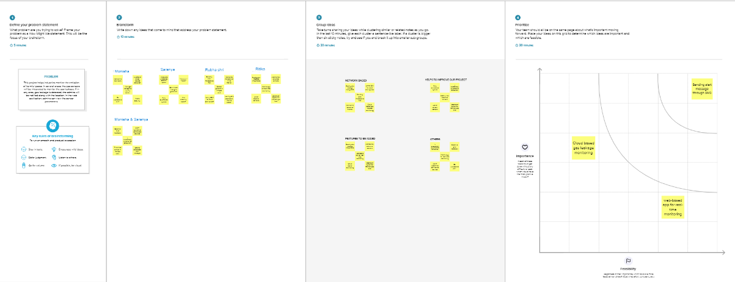

**PROPOSED SYSTEM**

In our system able to measure the usage of the gas per day by continuous measurement of the weight can be done using load cell. The same is displayed in the LCD, by using gas leakage sensor the leakage of the gas is sensed, it alerts the user through buzzer and also shut down the total power supply.

The following are the components used in this system

Components:

**Microcontroller:** A microcontroller (MCU for microcontroller unit, or UC for μ-controller) may be a tiny laptop on one microcircuit. It is a compact microcircuit designed to control a selected operation in associate embedded system. A typical microcontroller includes a processor, memory and input/output (I/O) peripherals on one chip. It contains one or a lot of CPUs (processor cores) beside memory and programmable input/output peripherals. Program memory within the type of ferroelectric RAM is additionally typically enclosed on chip, furthermore as a tiny low quantity of RAM.

**Load cell:** A load cell is a transducer that is used to convert a force into electrical signal. This conversion is indirect and happens in two stages. Through a mechanical arrangement, the force being sensed deforms a strain gauge. The strain gauge measures the deformation (strain) as an electrical signal, because the strain changes the effective electrical resistance of the wire.

**Power supply:** Power supply is a device that converts one voltage to another more convenient voltage while delivering power. Power supplies are designed from the output back to the input.

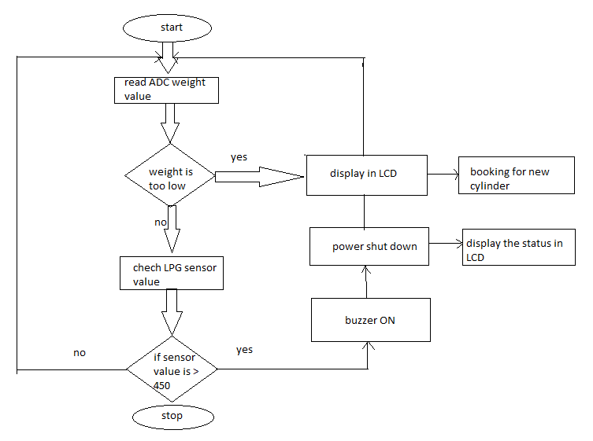

**Flow Diagram**

In our system we are implemented a module to overcome these issues faced by the society LOBO is a system which is incorporated with gas sensor to sense the gas outflow. If the sensor senses the gas outflow level and compare this with the threshold value which is already set in the software. If it exceeds the fixed threshold value means buzzer gets activated and relay which is connected to the circuit also switched on. Then the total power supply will be shut down. Now a day the peoples are unaware of the usage of the gas per day it leads to be delay in refilling the LPG cylinder. Our LOBO has one more module to overcome this kind of difficulties. Load sensor is used to continuously monitoring the level of the gas; Output of the load cell is connected to the microcontroller. Microcontroller manipulates that data weight of the gas cylinder, level of the gas leakage, usage of the gas per day are displayed in LCD. If the level of the gas cylinder gets critically low the new cylinder is booked automatically and the status is uploaded to the user through the Wi-Fi module

**Features:**

Some of the advantages are:

* This paper deal with the concept of monitoring a gas cylinder.
* Here the consumption level is continuously monitored.
* It also detects gas leakage and shuts down the power.

In our LOBO system there are two important modules are there they are

* + Gas outflow detection with brownout
  + Gas level monitoring with automatic booking

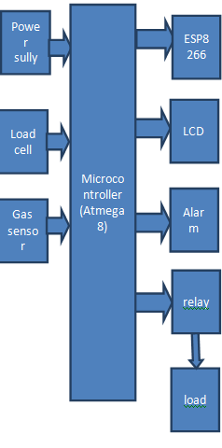

**Block Diagram for LOBO System**

Modules:

**Gas level monitoring with automatic booking:**

* **Load cell:** It is a force [transducer](https://en.wikipedia.org/wiki/Transducer). It converts a [force](https://en.wikipedia.org/wiki/Force)  into an electrical signal that can be measured. As the force applied to the load cell increases, the electrical signal changes comparatively. The most common types of load cell used are strain gauges, pneumatic, and hydraulic.
* In our system able to measure the usage of the gas per day by continuous measurement of the weight it can be done using load cell. The load cell is connected to the microcontroller. The operations which are performed by the microcontroller are send to the LCD. In LCD there are four major things are there. They are weight of the gas cylinder, usage of the gas per day, level of the gas leakage: The gas leakage level is exceed the fixed value means microcontroller send the signal to the buzzer and the buzzer get activated after that relay gets switched on and the total power supply will be shut down in a particular place, status of the gas cylinder: If the level of the gas is normal then it displayed the status as “normal”, If the level of the gas gets reduced it display the status as “reduced”, If the level of gas gets reduced to the critical level then it displays the status as “empty”. And also new cylinder is booked automatically through Wi-Fi module

**Gas outflow detection with brownout:**

* **Gas Sensor:** This detects the presence of gases in the environment. Based on the concentration of the gas the sensor produces a consequent potential difference by varying the resistance of the material inside the sensor, which can be measured as output voltage. Based on this voltage value the type and concentration of the gas can be predictable. The various types of gas sensors based on the sensing elements that are generally used in various applications: Metal Oxide based gas Sensor, Optical gas Sensor, Electrochemical gas Sensor, Capacitance-based gas Sensor, Calorimetric gas Sensor, Acoustic based gas Sensor.
* In our LOBO system the gas sensor is used to detect the gas outflow from the cylinder. The gas sensor output is integrated with buzzer as well as relay. The sensor senses the gas outflow level and compares that with the threshold value which is specified in the source code. If the out-flow level is high then the buzzer is switched on after that the relay also gets on. This works is needed to brownout the total power in a particular place.
* **LCD**: LCD includes some microwatts for show compared to some mill watts. Liquid crystal display could be a combination of 2 states of matter, the solid and therefore the liquid. Liquid is employed to provide a comprehensible image in liquid crystal display. The liquid crystal display works on the principle of obstruction lightweight. When compared to LED and cathode ray tube, LCD is thinner. Blocking light principle is used for the working of LCD. This is used to display the weight of the gasoline content.
* **Microcontroller:** A microcontroller (MCU for microcontroller unit or UC for μ-controller) may be a tiny laptop on one microcircuit. It’s a compact microcircuit designed to control a selected operation in associate embedded system. A typical microcontroller includes a processor, memory and input/output (I/O) peripherals on one chip. It contains one or a lot of CPUs (processor cores) beside memory and programmable input/output peripherals. Program memory within the type of ferroelectric RAM is additionally typically enclosed on chip, furthermore as a tiny low quantity of RAM.

**Problem Solution Fit**

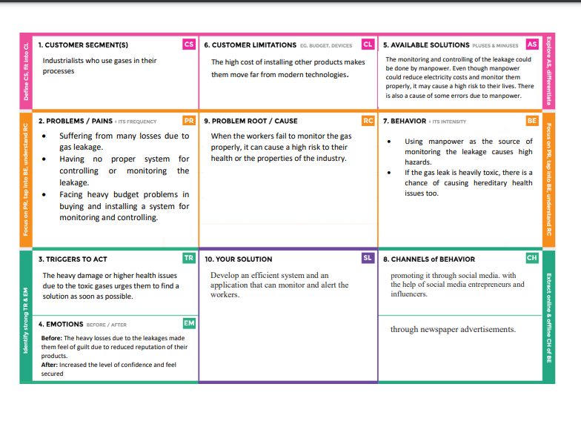

**REQUIREMENT ANALYSIS**

**Functional requirement**

Team Name:

Monisha G

Saranya S

Ritika G

Rubha shri V

|  |  |
| --- | --- |
| Date | 15 October 2022 |
| Team ID | PNT2022TMID35759 |
| Project Name | Project – Gas Leakage Monitoring and Alerting  System |
| Maximum Marks | 4 Marks |

# 

Following are the functional requirements of the proposed solution.

|  |  |  |
| --- | --- | --- |
| **FR No.** | **Functional Requirement (Epic)** | **Sub Requirement (Story / Sub-Task)** |
| FR-1 | Objective | The purpose of the system is to detect early gas leakage  in the industries through the gas pipelines and alert the user with their location. |
| FR-2 | Focus | To alert the user immediately if any gas leakage is  sensed. |
| FR-3 | Features | Gas leakage level will be indicated by the LED lights. It detects the different harmful gases like methane, LPG etc., by using the required sensors. It updates the  sensor parameters in web applications. |
| FR-4 | Essentiality | To prevent the industry workers from being exposed to  toxic gases. |
| FR-5 | Gas leakage location sent | Location sent to the web application through GPS  module. |

# 

# **NON-FUNCTIONAL REQUIREMENTS**

Following are the non-functional requirements of the proposed solution.

|  |  |  |
| --- | --- | --- |
| **FR No.** | **Non-Functional Requirement** | **Description** |
| NFR-1 | **Usability** | The web application is simple and easy to use.  Efficiency is high. |
| NFR-2 | **Security** | The application runs accurately. |
| NFR-3 | **Reliability** | The application can be accessed at anytime and  anywhere |
| NFR-5 | **Availability** | The web application is highly secure. Software is  protected from unauthorized access |
| NFR-6 | **Scalability** | Application is not limited to the users. |

**PROJECT DESIGN**

**Data Flow Diagrams**

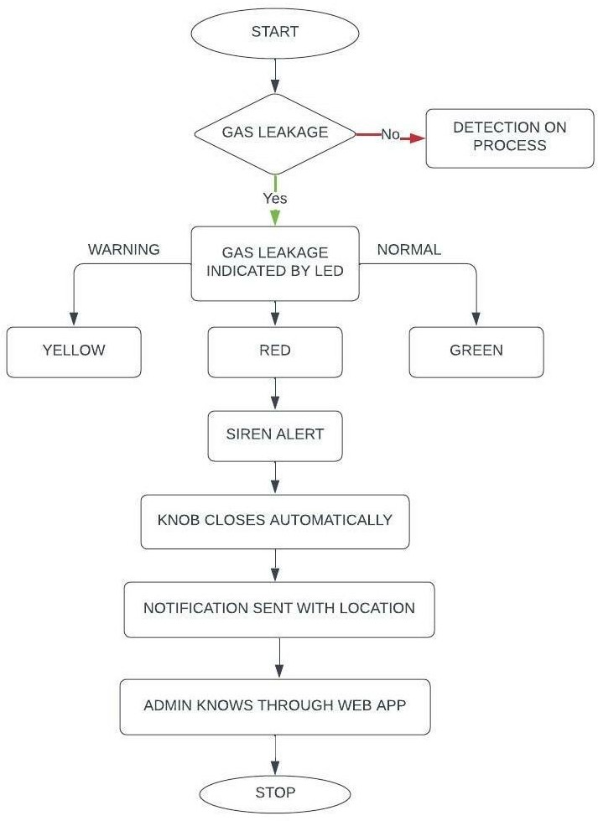

**Solution & Technical Architecture**

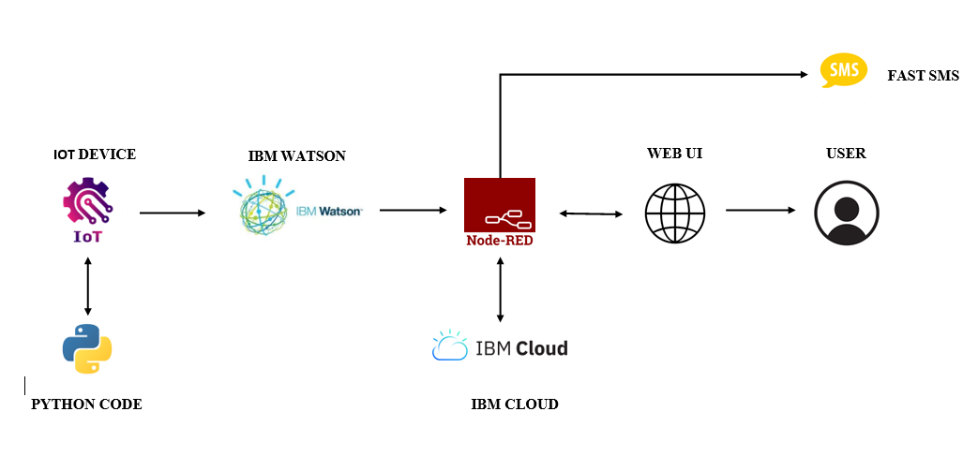

**USER STORIES**

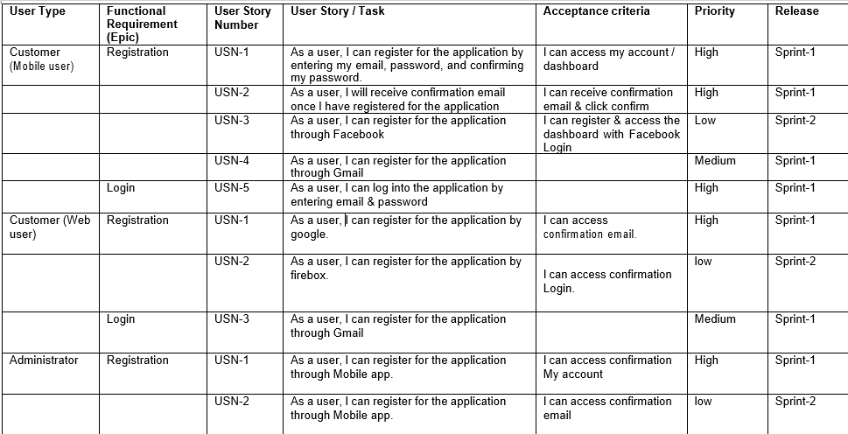

**PROJECT PLANNING & SCHEDULING**

**Sprint Planning & Estimation**

1. Identify the problem
2. Prepare a abstract, problem statement
3. List a required object needed
4. Create a code and run it
5. Make a prototype
6. Test with the created code and check the designed prototype is
7. Solution for the problem is found

**Sprint Delivery Schedule**

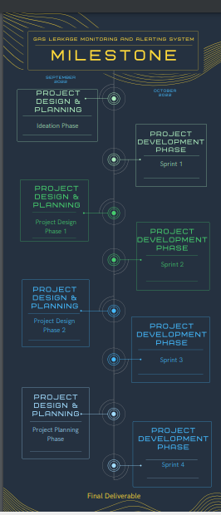

**REPORTS FROM JIRA**

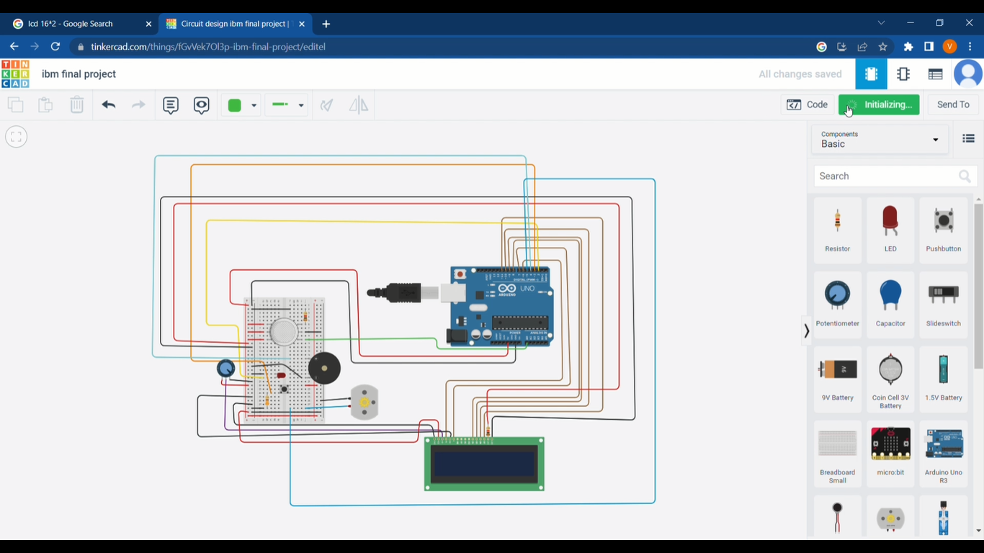

**LOBO SYSTEM**

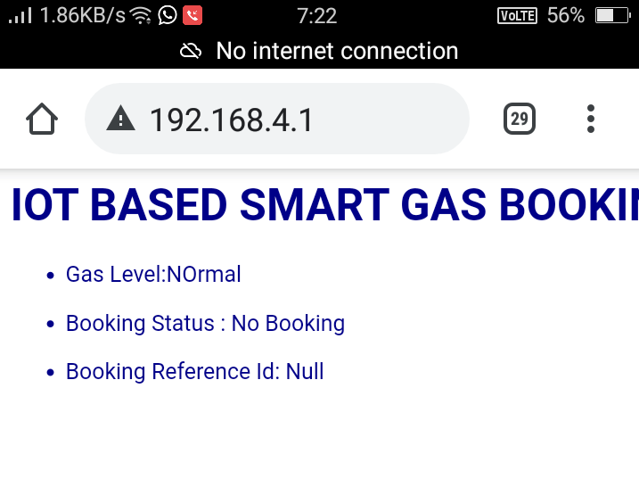

**OUTPUT WHEN GAS LEVEL IS IN THE NORMAL LEVEL.**

**CODING AND SOLUTION**

#include <LiquidCrystal.h>

LiquidCrystal lcd(5,6,8,9,10,11);

int redled = 2;

int greenled = 3;

int buzzer = 4;

int sensor = A0;

int sensorThresh = 400;

void setup()

{

pinMode(redled, OUTPUT);

pinMode(greenled,OUTPUT);

pinMode(buzzer,OUTPUT);

pinMode(sensor,INPUT);

Serial.begin(9600);

lcd.begin(16,2);

}

void loop()

{

int analogValue = analogRead(sensor);

Serial.print(analogValue);

if(analogValue>sensorThresh)

{

digitalWrite(redled,HIGH);

digitalWrite(greenled,LOW);

tone(buzzer,1000,10000);

lcd.clear();

lcd.setCursor(0,1);

lcd.print("ALERT");

delay(1000);

lcd.clear();

lcd.setCursor(0,1);

lcd.print("EVACUATE");

delay(1000);

}

else

{

digitalWrite(greenled,HIGH);

digitalWrite(redled,LOW);

noTone(buzzer);

lcd.clear();

lcd.setCursor(0,0);

lcd.print("SAFE");

delay(1000);

lcd.clear();

lcd.setCursor(0,1);

lcd.print("ALL CLEAR");

delay(1000);

}

}

#include <LiquidCrystal.h>

LiquidCrystal lcd(5,6,8,9,10,11);

int redled = 2;

int greenled = 3;

int buzzer = 4;

int sensor = A0;

int sensorThresh = 400;

void setup()

{

pinMode(redled, OUTPUT);

pinMode(greenled,OUTPUT);

pinMode(buzzer,OUTPUT);

pinMode(sensor,INPUT);

Serial.begin(9600);

lcd.begin(16,2);

}

void loop()

{

int analogValue = analogRead(sensor);

Serial.print(analogValue);

if(analogValue>sensorThresh)

{

digitalWrite(redled,HIGH);

digitalWrite(greenled,LOW);

tone(buzzer,1000,10000);

lcd.clear();

lcd.setCursor(0,1);

lcd.print("ALERT");

delay(1000);

lcd.clear();

lcd.setCursor(0,1);

lcd.print("EVACUATE");

delay(1000);

}

else

{

digitalWrite(greenled,HIGH);

digitalWrite(redled,LOW);

noTone(buzzer);

lcd.clear();

lcd.setCursor(0,0);

lcd.print("SAFE");

delay(1000);

lcd.clear();

lcd.setCursor(0,1);

lcd.print("ALL CLEAR");

delay(1000);

}

}

**FEATURE 1**

* This paper deal with the concept of monitoring a gas cylinder.
* Here the consumption level is continuously monitored.
* It also detects gas leakage and shuts down the power
* High Sensitivity
* High sensitivity to Ammonia, Sulfide, and Benze
* Stable and Long Life
* Detection Range: 10 – 300 ppm NH3, 10 – 1000 ppm Benzene, 10 – 300 Alcohol

**FEATURE 2**

* This project helps the industries in monitoring the emission of harmful gases
* In several areas, the gas sensors will be integrated to monitor the gas leakage
* If in any area gas leakage is detected the admins will be notified along with the location
* In the web application, admins can view the sensor parameters.

**ADVANTAGES & DISADVANTAGES**

ADVANTAGES

* Get real-time alerts about the gaseous presence in the atmosphere
* Prevent fire hazards and explosions
* Supervise gas concentration levels
* Ensure worker’s health
* Real-time updates about leakages
* Cost-effective installation
* Get immediate gas leak alerts

DISADVANTAGES

* Only one gas can be measured with each instrument.
* When heavy dust, steam or fog blocks the laser beam, the system will not be able to take measurements. This is also the case when a person or vehicle blocks the path.

**CONCLUSION**

To shorted out the problems faced by LPG gas consumers, here come up with some solutions to meet the few requirements of them. To make our system is completely automate the process of refill booking without human intervention. Our system is also help customers to upgrade their safety norms. The main motto of our project is to monitor the gas present in the cylinder and displayed it to user and also the new cylinder is booked automatically through the Wi-Fi module when the gas gets emptied. Another motto of our project is to detect the gas leakage through the gas sensor it activates the buzzer and shut down the total power supply.

**FUTURE SCOPE**

IoT turns drone into gas detection sensor. Another major future scope could be including an Automatic Shut-off device which will turn off the gas supply whenever it will detect any gas leakage. This system can be implemented in Industries, Hotels and wherever the LPG cylinders are used.

**APPENDIX**

**SCREENSHOTS**

**LOBO SYSTEM**



**OUTPUT WHEN GAS LEVEL IS IN THE NORMAL LEVEL.**

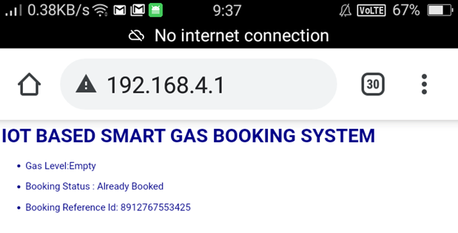

**OUTPUT STATUS WHEN GAS LEVEL IS IN EMPTY LEVEL**

**SOURCE CODE**

#include <LiquidCrystal.h>

LiquidCrystal lcd(6, 7, 8, 9, 10, 11);

float gasPin = A0;

float gasLevel;

int ledPin = 2;

int buttonPin = 3;

int buzzPin = 4;

int buttonState;

int fan = 5;

void setup(){

pinMode(ledPin, OUTPUT);

pinMode(buttonPin, INPUT);

pinMode(gasPin,INPUT);

pinMode(fan,OUTPUT);

Serial.begin(9600);

lcd.begin(16, 2);

lcd.setCursor(0,0);

lcd.print(" Welcome");

lcd.setCursor(0,2);

lcd.print("GAS LEAKAGE SYSTEM");

delay(500);

lcd.clear();

}

void loop(){

// Read the value from gas sensor and button

gasLevel = analogRead(gasPin);

buttonState = digitalRead(buttonPin);

// call the function for gas detection and button work

gasDetected(gasLevel);

buzzer(gasLevel);

exhaustFanOn(buttonState);

}

// Gas Leakage Detection & Automatic Alarm and Fan ON

void gasDetected(float gasLevel){

if(gasLevel >= 300){

digitalWrite(buzzPin,HIGH);

digitalWrite(ledPin,HIGH);

digitalWrite(fan,HIGH);

lcd.setCursor(0,0);

lcd.print("GAS:");

lcd.print(gasLevel);

lcd.setCursor(0,2);

lcd.print("FAN ON");

delay(1000);

lcd.clear();

}else{

digitalWrite(ledPin,LOW);

digitalWrite(buzzPin,LOW);

digitalWrite(fan,LOW);

lcd.setCursor(0,0);

lcd.print("GAS:");

lcd.print(gasLevel);

lcd.setCursor(0,2);

lcd.print("FAN OFF");

delay(1000);

lcd.clear();

}

}

//BUZZER

void buzzer(float gasLevel){

if(gasLevel>=300)

{

for(int i=0; i<=30; i=i+10)

{

tone(4,i);

delay(400);

noTone(4);

delay(400);

}

}

}

// Manually Exhaust FAN ON

void exhaustFanOn(int buttonState){

if(buttonState == HIGH){

digitalWrite(fan,HIGH);

lcd.setCursor(0,0);

lcd.print("Button State:");

lcd.print(buttonState);

lcd.setCursor(0,2);

lcd.print("FAN ON");

delay(10000);

lcd.clear();

}

}

## PROJECT GITHUB LINK :

<https://github.com/IBM-EPBL/IBM-Project-32252-1660208835>

## PROJECT DEMO LINK :

<https://drive.google.com/file/d/1AIm7JNK0qRq0Tbatces50fgqsYkae5BW/view?usp=drivesdk>